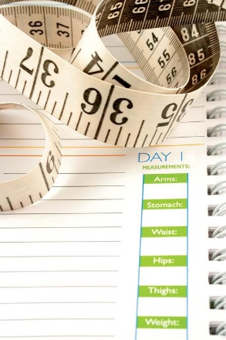

**YOUR LOGO HERE**

**555.543.5432**

**yourwebsitehere.com**

**5432 Any Street West**

**Townsville, ST 54321**

It all starts with a FREE initial weightloss

consultation.

Et iusto odio dignissi

qui erat blandit praes luptatum dolo zzril

delenit tera augue dui dolore te feugait nulla facilisi lorem ipsum

dolore sitte ameteris

con sectetuer wisi.

5

Educational Resources

Eros et accumsan et iusto odio duis autem vel eum iriure dolor in hendrerit in duis autem vel eum iriure dolor in hendrerit in vulpu dolore eu feugiat nulla facilisis vero.

4

Nutritional Information

Duis autem vel eum iriure dolor in hendrerit in vulputate velit esse molestie consequat, vel illum dolore eu feugiat nulla facilisis at vel eum iriure dolor in hendrerit in.

3

Physical Activity

Accumsan consequat, vel erat ill dolore erat eu feugiat nulla facilisis at vero ero et accumsan et iusto odio duis autem vel eum iriure dolor in hendrerit in vulputate.

2

Motivational Support

Vel illum dolore eurae feugiat null facilisis at vero eros et accumsan et iusto odi duis autem vel eum iriure dolor in hendrerit in vulputate velit esse molestie consequat.

1

Medical Research

Duis autem vel eum iriure dolor in hendrerit in vulputate velit esse molestie quat, vel illum dolore eu feugiat nulla facilisis vero eros et accumsan et iusto in hendrerit.

THE 5 KEYS TO SUCCESS:

Et iusto odio dignissim qui blandit praesent luptatum zzril delenit augue duis dolore tera feugait nulla facilisi dolor sit ame.

***Take Charge.***